# Adding a Custom Visualization

Users now have the ability to integrate custom visualizations into Web and Desktop dashboards. This is one of the advantages of moving to an HTML5 interface, as it allows third party integration with external libraries such as the popular D3 visualizations. These custom visualizations have the ability to work just like any other OOTB visualizations.

For this exercise we will be using a previously packaged Bubble Graph.

1. Save your work (File > Save) and then **close** the Desktop Application

## Windows users:

Browse to wherever you saved your **D3BubbleChart** file package (included in the Supporting Files):

Unzip the folder and drop the content into this location:

## C:\Program Files\MicroStrategy\MicroStrategy Desktop\code\plugins

(you may need to create the plugins folder)

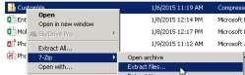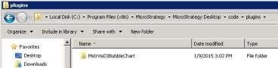

## For Mac users:

Navigate to the **Applications** folder in the **Finder** window. Right click on the **MicroStrategy Desktop app icon**, and choose **Show Package Contents** from the available options. Navigate to the following location (**Contents\Resources\code\plugins**) and drop the **MstrVisD3BubbleChart** folder in the **Plugins** folder ***NOTE:*** you may need to manually create the plugins folder

1. Start Desktop application and notice the additional visualization in the **visualization gallery** on the right hand side

